ASSIGNMENT

SUBJECT :20MCA107 - Advanced Software Engineering

Topic:Centralized Version control system

TO,

Mr. Rahulnath H.A
Assistant Professor
Department of MCA

FROM,

Arjun V Pankajakshan
Roll No- 38
D₁ MCA

To work in a centralised version control system ,i choosed Apache Subversion and installed in my ubuntu.To create a new repository i used the following commands.

$ sudo mkdir -p /opt/svn

$ sudo svnadmin create /opt/svn/sampleproject

$ sudo chown -R www-data:www-data /opt/svn/sampleproject/

$ sudo chmod -R 775/ opt/svn/sampleproject

To add Subversion user used the following command and given a password.

$ sudo htpasswd -cm /etc/svn-auth-users arjun

To Apache virtual host file for SVN ,changed the directory using the following command
$ cd /etc/apache2/sites-available/

The created a virtual host file by following command
$ sudo gedit samprojectsvn.conf
Added following lines to file.

<VirtualHost *:80>
ServerName arjun
ServerAlias arjun
<Location /svn>
DAV svn
SVNParentPath /opt/svn
AuthType Basic
AuthName "Subversion Repository"
AuthUserFile /etc/svn-auth-users
Require valid-user
</Location>
ErrorLog ${APACHE_LOG_DIR}/arjun-error.log
CustomLog ${APACHE_LOG_DIR}/arjun-access.log combined
</VirtualHost>

Then saved and exit the file.
To stop default host file used following command,
sudo a2dissite 000-default.conf
Then enabled newly created virtual host file and restarted apache by follwing command .
$ sudo a2ensite samprojectsvn.conf
$ sudo apachectl -t
$sudo systemctl restart apache2
To view the created repository by going to the browser and using following link ,http://arjun/svn/sampleproject/
Then will get the Authentication popup screen like below, enter the already created Username and Password to access svn repository.
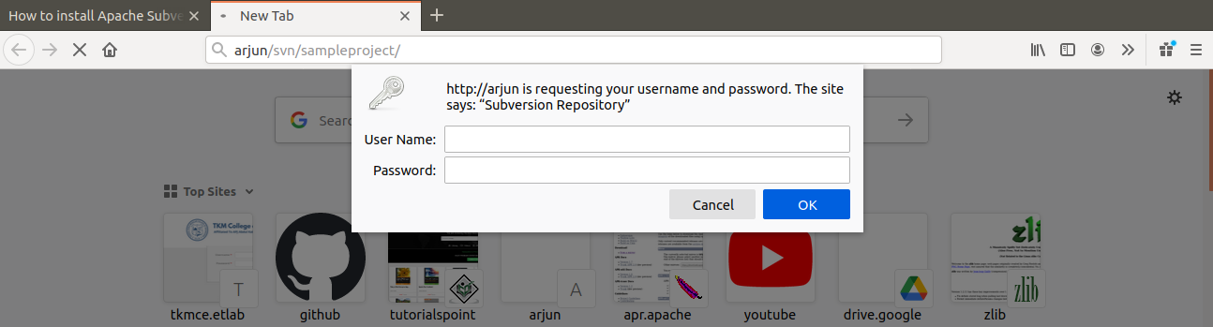

After authentication it redirects to the repository like below.
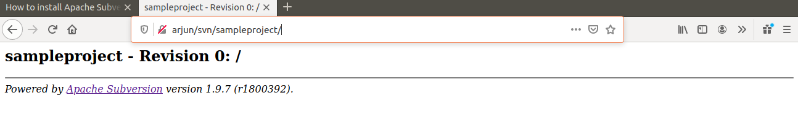
To create a new project called “myproject ” inside the repository.
$ sudo svn mkdir file:///opt/svn/sampleproject/myproject -m "added myproject repository"
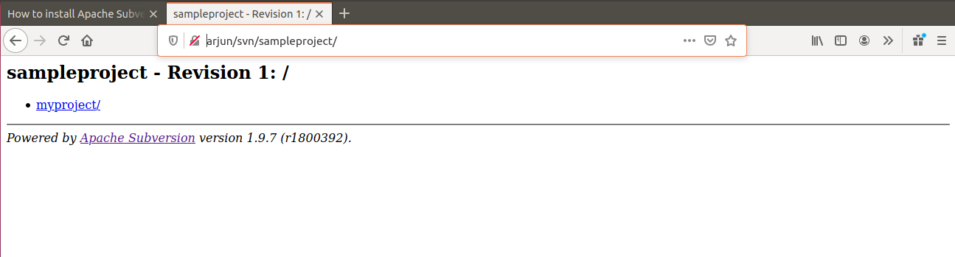
$ sudo svn mkdir file:///opt/svn/sampleproject/myproject/project1 -m "added project1 to repository"
$ sudo svn mkdir file:///opt/svn/sampleproject/myproject/project2 -m "added project2 to repository"
$ sudo svn mkdir file:///opt/svn/sampleproject/myproject/project3 -m "added project3 to repository"
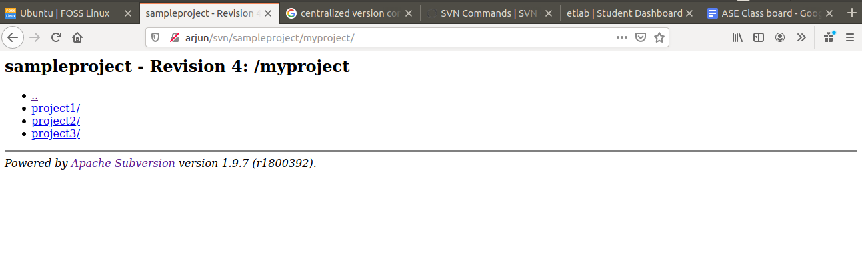
Click and Open “myproject”,which view like below,
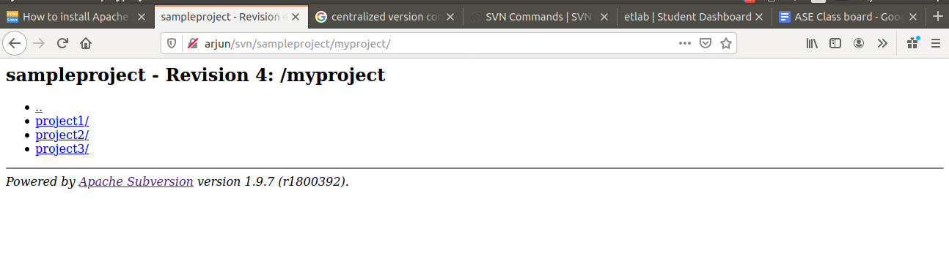
To delete a created project,
$ sudo svn delete file:///opt/svn/sampleproject/myproject/project3 -m "delete project3 repository"
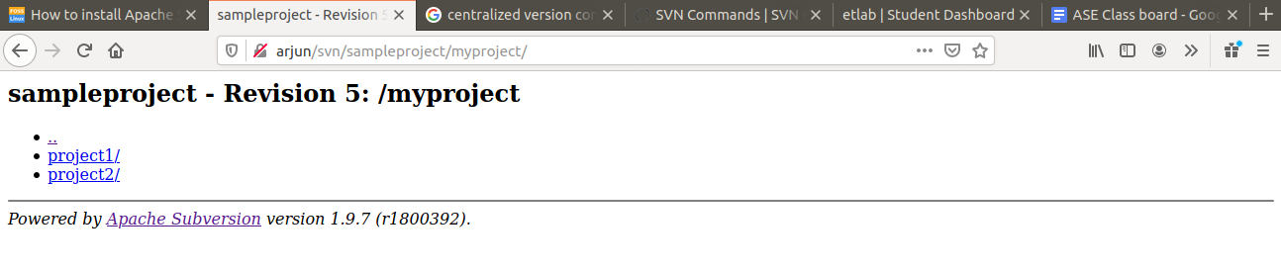
SVN Checkout
Checkout command is used to download sources from SVN repository to working copy.
$ sudo svn checkout http://arjun/svn/sampleproject/

SVN Add

To add a new file (or directory) to the repository we use SVN add command.
$ sudo svn add readme.txt

SVN commit

Whenever the changes to the working copy, it will not reflect in SVN server. To make the changes permanent, need to do SVN commit.

$ sudo svn commit -m "adding readme.txt "readme.txt

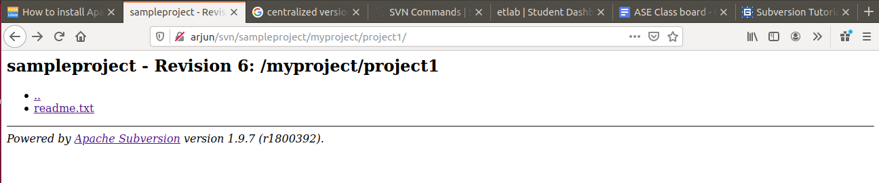

SVN Status
Use svn status command to get the status of the file in the working copy. It displays whether the working copy is modified, or its been added/deleted.
After modifying readme.txt
$ sudo svn status

SVN Diff
SVN diff displays the differences between your working copy and the copy in the SVN repository.
Added a new file called new.txt and checking the difference by following commands.

$ sudo svn add new.txt
$ sudo svn diff
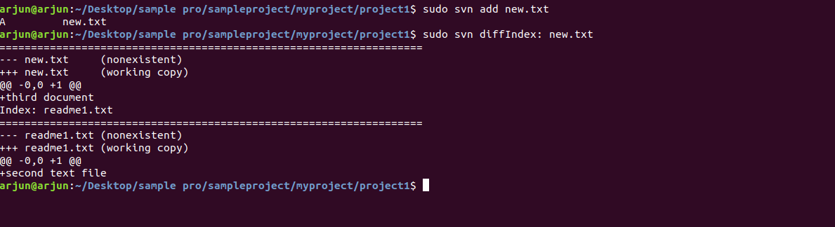
After commit server repository updates as given below.
